**Week 15-01:**

**Name:Snehan.S**

**Roll no:24801272**

**1.** Given an array of integers, reverse the given array in place using an index and loop rather than a built-in function.

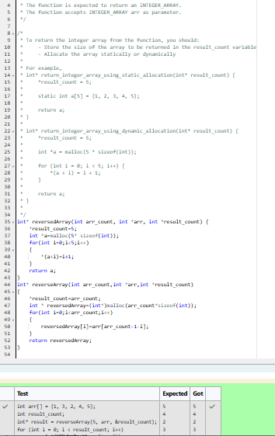

2. An automated cutting machine is used to cut rods into segments. The cutting machine can only hold a rod of minLength or more, and it can only make one cut at a time. Given the array lengths [] representing the desired lengths of each segment, determine if it is possible to make the necessary cuts using this machine. The rod is marked into lengths already, in the order given.

